How to use the TODAY() and NOW() Functions in Excel

The TODAY() Function is used to determine the current date, as in the date one is actually opening the workbook. This function updates automatically, so let’s say you open the workbook on 1 April 2017, the TODAY() Function will reflect that date, if you next open the workbook on 18 April 2017, the TODAY() Function will reflect that date. The TODAY() Function does not take any arguments and the syntax is:
=TODAY()
The NOW() Function is used to return the current date as well as the current time. It also does not take any arguments and the syntax is:
=NOW()

So let’s get started with a few simple examples to show how to use the TODAY() Function and the NOW() Function.

Introduction

We have a spreadsheet showing some data of an employee working for a company. Details such as the employee’s name, department and total sales are recorded. The source data is shown below.
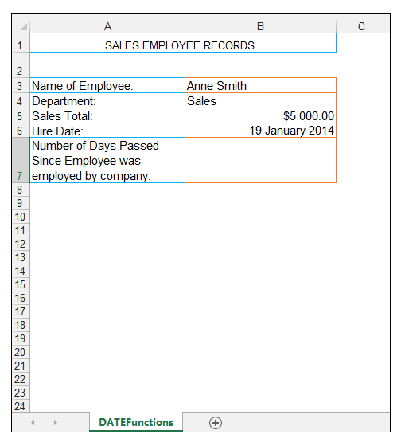
1) In order to show the current date in cell A2, we enter the formula:

=TODAY()

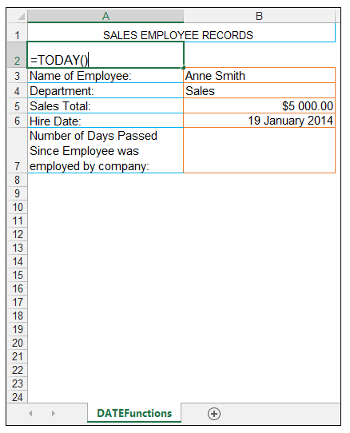

2) Upon pressing CTRL-ENTER, the value of 6/21/2017 is returned, which is the current date, at the time of opening the workbook.

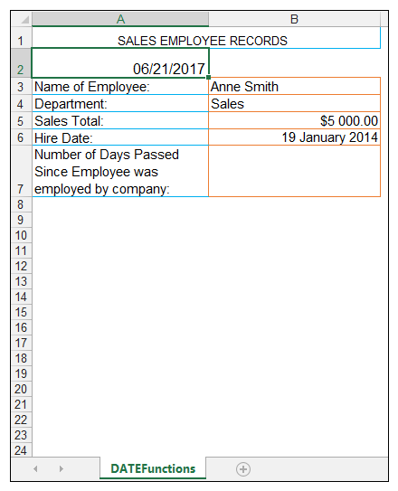

3) If the workbook is opened on the following day, this date would update automatically to 6/22/2017.

4) We now want to format this date, in order to have it appear as a long date, so in order to do this with cell A2 selected, we go to Home>Number> and then we select Long Date.
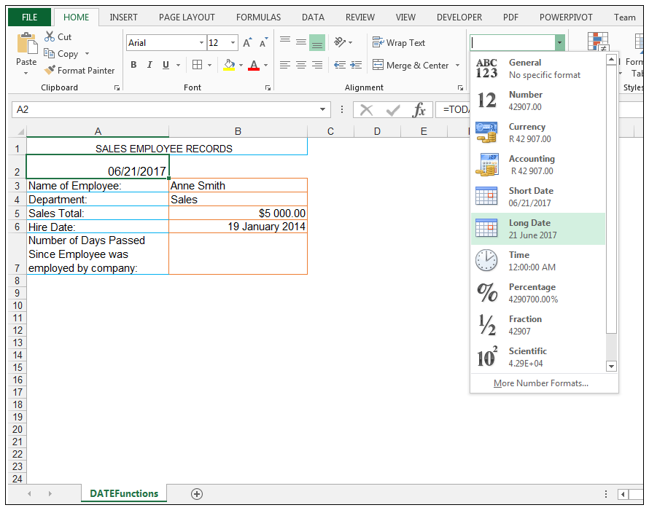

5) The date returned is now formatted as a Long Date as shown below.
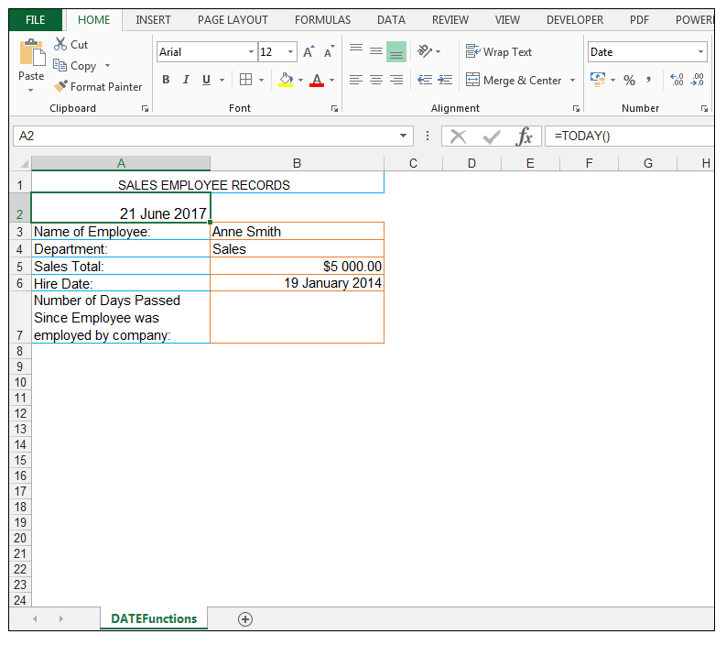

Using the TODAY Function in a formula in order to determine the number of days that have passed since the Employee was hired

1) We now want to calculate the number of days it’s been since the employee was hired, and we could hard code the date into a formula, however we want the formula to update, so as the workbook, is opened the number of days is updated based on the current date the workbook is opened on.

2) Therefore in cell B7, we enter the following formula:
=DAYS(TODAY(),B6)

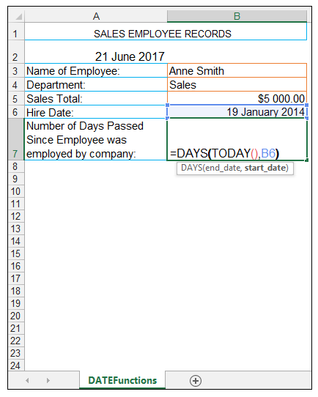

3) Upon pressing CTRL-ENTER we get the value of 1249 returned, which means 1249 days have passed since the hire date of the employee at hand and the current date of opening the workbook which was 21 June 2017.
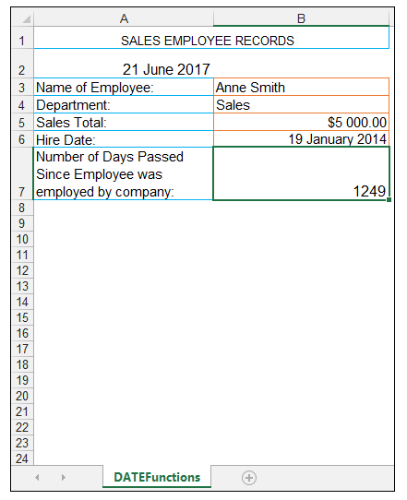

4) Ensure the number format in cell B7 is General, in order to see the number of days that has passed or else one may get an actual date shown.
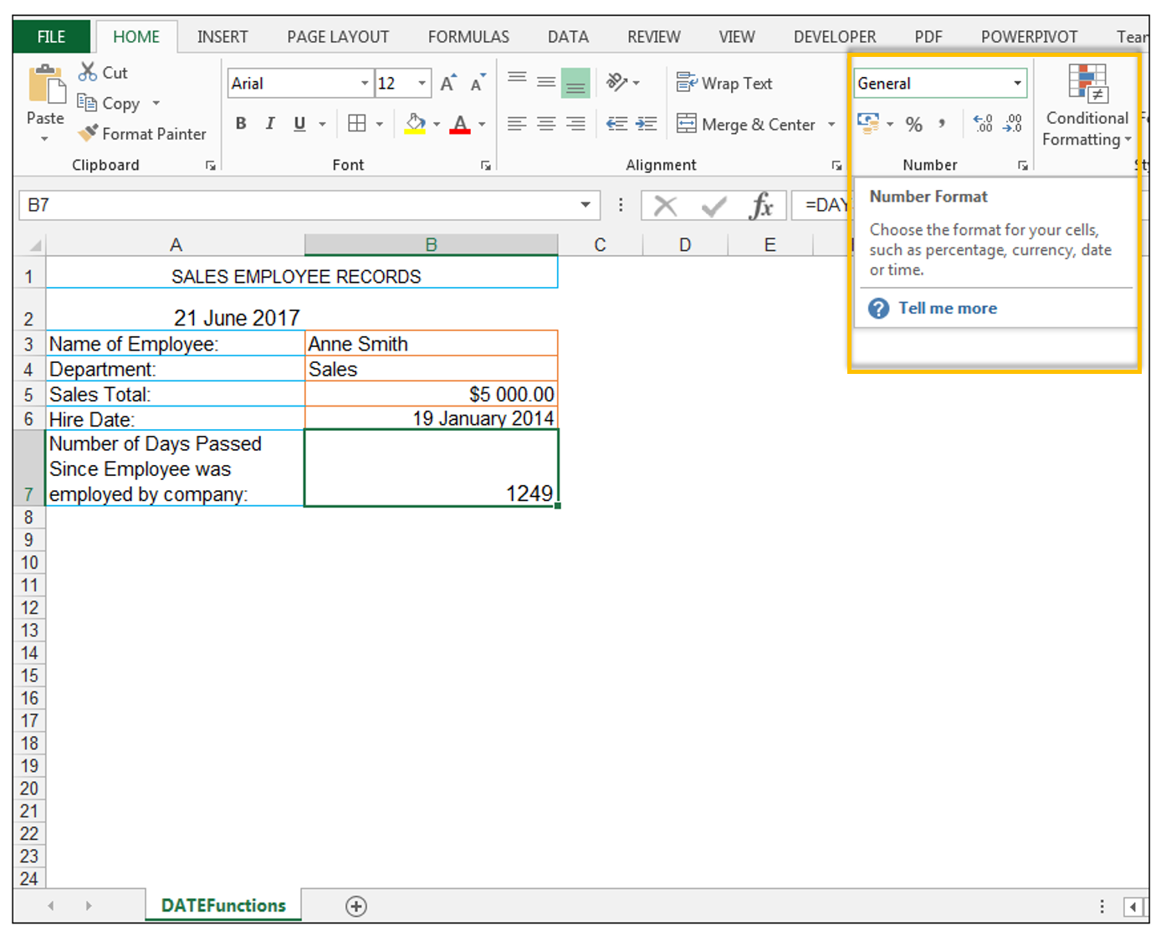

How to Use the NOW() Function

1) We would now like to obtain not only the current date, but the current time in conjunction with the date, so we can utilize the NOW Function() for this specific purpose.

2) So in cell B2, we type the following formula:

=NOW()

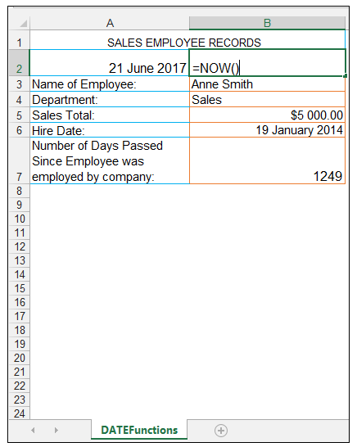

3) Upon pressing CTRL-ENTER we get the current date and time returned as shown below.
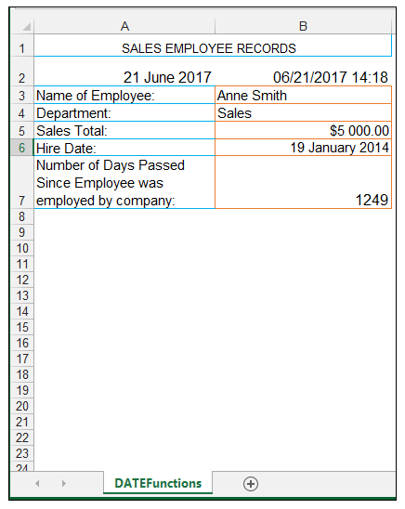

4) If one wants to format this with a long date format with the time, right-click the cell and choose Format Cells as shown below.
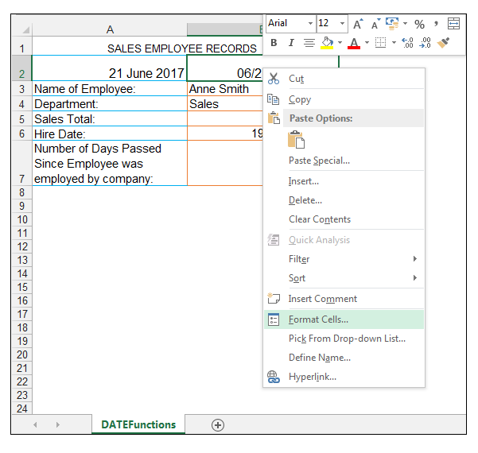

5) In the Format Cells Dialog Box, select Custom and enter:

dd mmmm yyyy hh:mm

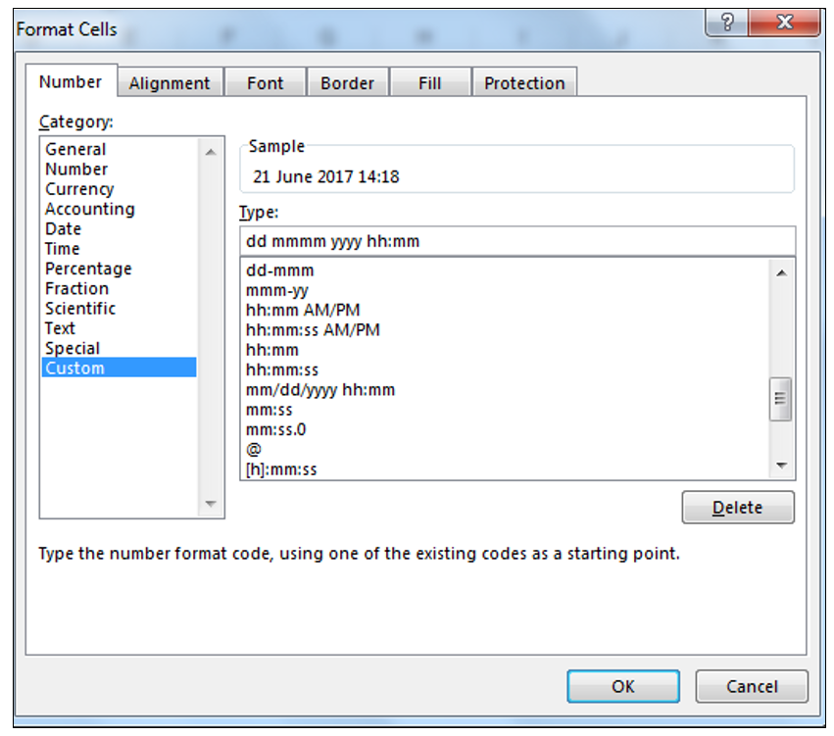

6) Press Ok and then the long date and time is shown, as shown below.

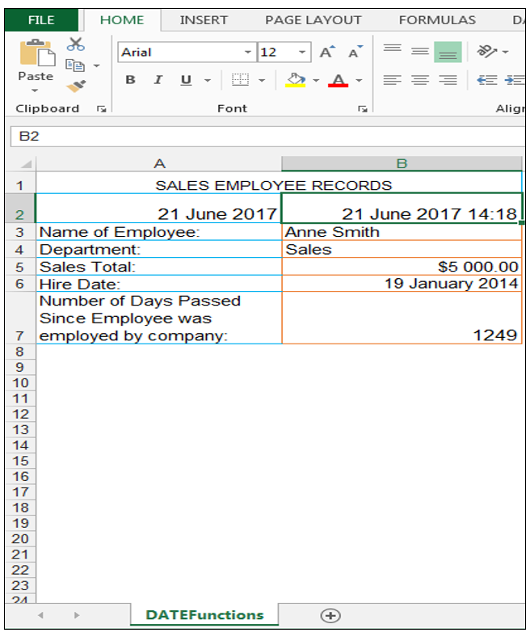

And there you have it.

Conclusion

The TODAY() and NOW() Functions take no arguments but are useful for delivering the current date and time. They also can be utilized in other date calculations for advanced date and time calculations.

Please feel free to comment and tell us if you often use the TODAY() and NOW() Functions in your spreadsheets.

Useful Links:
TODAY Function
NOW Function

